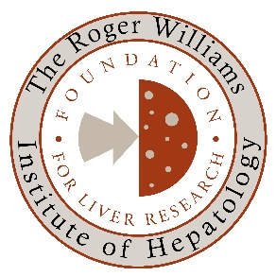

Foundation for Liver Research

Small Grants Scheme

Application Form

Applications will be considered against the following criteria:

- Potential for clinical benefit to patients with liver disease
- Potential for the proposed research to inform further studies
- Feasibility of proposed project and its likely outcomes
- Track record of applicant(s)
- Value for money
- Relevance to the objectives of the Foundation for Liver Research

Details of Primary applicant
Title
Full name
Position
Department and institution
Address
Telephone
Email
ORCID or link to Scopus author page | (optional)
Details of any co-applicants
(optional)

Project details

Title of project
Proposed start date
Duration (12-24 months)
Lay Summary
(250-500 words)

Background and rationale
(Max. 250 words)

Research aims
(Max. 150 words)

Materials & Methods
(Max. 500 words: please include existing ethics approval where applicable)

Intended outputs and impact
(Max. 750 words: to include scientific outputs, clinical impact, anticipated impact on career development)

How is this project relevant to the core objectives of the Foundation for Liver Research
(Max. 200 words)

Budget
Staff costs
Consumables
Equipment (max. £3000)
Other (insert additional rows below)
Please note: we are not able to pay indirect costs or overheads. Please also indicate whether there is financial or in-kind support from your host or other organisations.

Total sought from the Foundation for Liver Research
The Foundation will consider either two awards annually of up to £20,000 or a single award of £40,000.

For each applicant, please include a 2 page CV and an optional list of relevant and recent publications (maximum one page of A4).

Pre-submission enquiries should be directed to: Dr Shilpa Chokshi s.chokshi@researchinliver.org.uk

The application and supplementary paperwork should be submitted in pdf format to n.day@researchinliver.org.uk by 1st March 2022

